Course: CSC340.01  
- Student: <Keith> <Rich>  
- Assignment Number: 00  
- Assignment Due Date & Time: 06-12-2018 at 11:59

PART 1:

- Question 1: reply to ilearn



- Question 2: Navigate file manager



PART 2:

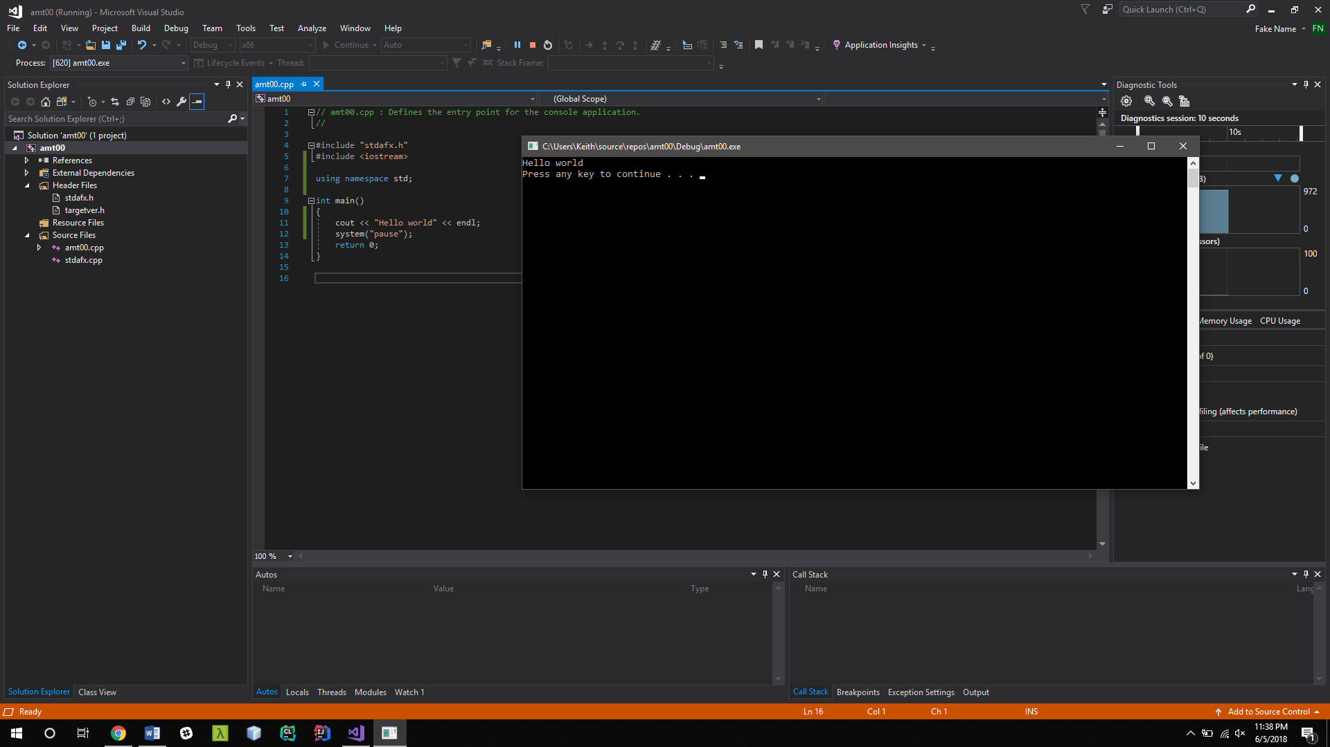

PART 3:

Both quick find and quick replace are going to be useful to me for obvious reasons.

Same for f5 and CTRL f5 for easy debugging or running.

Most of the step into or over functions will be utilized as well when debugging suing f10 and f11

I also will be using go to next error a lot so ctrl shift f12 will be used.

PART 4:

a. Your approach in implementing your program.

My first attempt was very cumbersome in the fact that I trying to make a large sum of if else statements and then compared them each by the user search. Once I had the idea of using a for loop to traverse the enums it became much easier to compare and I was able to make the code rather small. To implement the pro version, I added them as enums and converted the user string to both caps and removed whitespaces.

NOTE: CHANGE OF CODE

After class today, I relied that I had not used a data structure to complete the assignment other then enums so I had to update my code to incorporate a vector that stores the definitions and enums. I then later access said vector once I have found a match for the search query.

b. Which data structures did you use?

I used a vector to store the values associated with he enums then traversed the enums and output the position that the definition associated with the search choice.

c. What did you use the data structures for?

Storing the definitions of the enums

d. Why these data structures but not the others?

Simple, Strait forward, easy to interpret, fast.

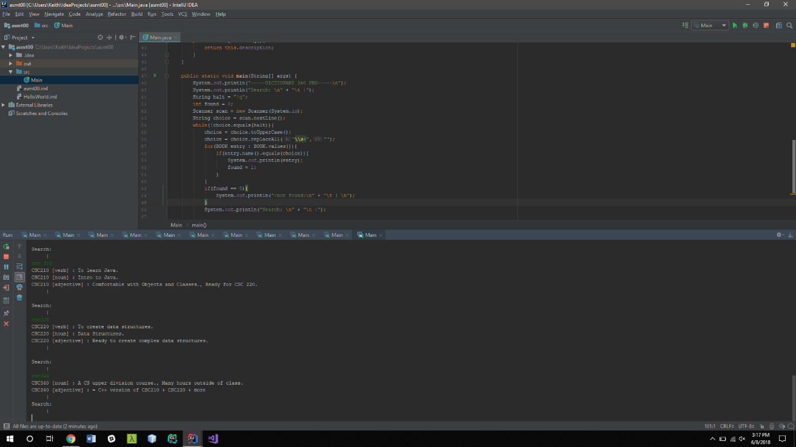

Note: I have built in **both** the Standard and Pro version into the same code. It all works fine for me.